Spending Plan Template
Month: ________________________________ Monthly Income (Net): _____________________
50/30/20% Breakdown
Net Income = Essentials (50%) + Lifestyle (30%) + Future (20%)
Essentials (Try for 50% or less of total expenses)
Housing | $
Utilities | $
Groceries | $
Car Payment | $
Gas | $
Insurance | $
Child Care | $
Total | $
Lifestyle (Try for 30% or less of total expenses)
Phone | $
Internet | $
Eating Out | $
Subscriptions | $
Hobbies/Entertainment | $
Clothing/Personal Care | $
Pet Expenses | $
Total | $
Future (Try for 20% or more of total expenses)
Savings (Try for at least 10% of your monthly income) | $
Investing | $
Credit Card Payment(s) | $
Student Loan Payment(s) | $
Other Misc. Debt Payment(s) | $
Total | $
Net Income - Total Expenses = Left Over

Creating a Successful Spending Plan
Creating a Successful Spending Plan
A budget is simply a plan for how you’ll use your money. Having a plan ensures you can cover your bills and other obligations while also making room for the things that are important to you and your lifestyle. Finally, it allows you to ‘Pay Yourself First', helping you build financial security and set yourself up for long-term success.
To create your budget, you’ll start by determining your average net income – the amount deposited into your bank account each month. If your income varies, use the lowest expected amount to create a cushion. Next, outline your monthly expenses and see how they align with the 50/30/20% Guideline.
50/30/20% Guideline: What is It?
This method, recommended by financial experts, suggests allocating 50% of your income to Essentials (needs), 30% to Lifestyle (wants), and 20% to your Future (Savings/Investing/Debt). Using this framework can be especially helpful when making large financial decisions, such as like renting an apartment, buying a car, or purchasing a home.
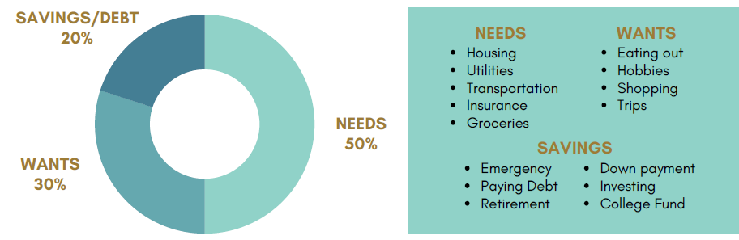

Setting Yourself Up for Success
A spending plan isn’t a one-time task – it’s an ongoing habit! Track your spending regularly using a budgeting app, spreadsheet, or even a notebook. Adjust your budget as needed to stay on track, especially when your income or expenses change.
Remember, a good budget gives you control over your money, allowing you to spend with confidence instead of stress. No month will be perfect, but you’re consistently spending more than you earn or are struggling to make ends meet, NCCYou has many resources to help. Visit NCCYou.com/FLi to learn more!

